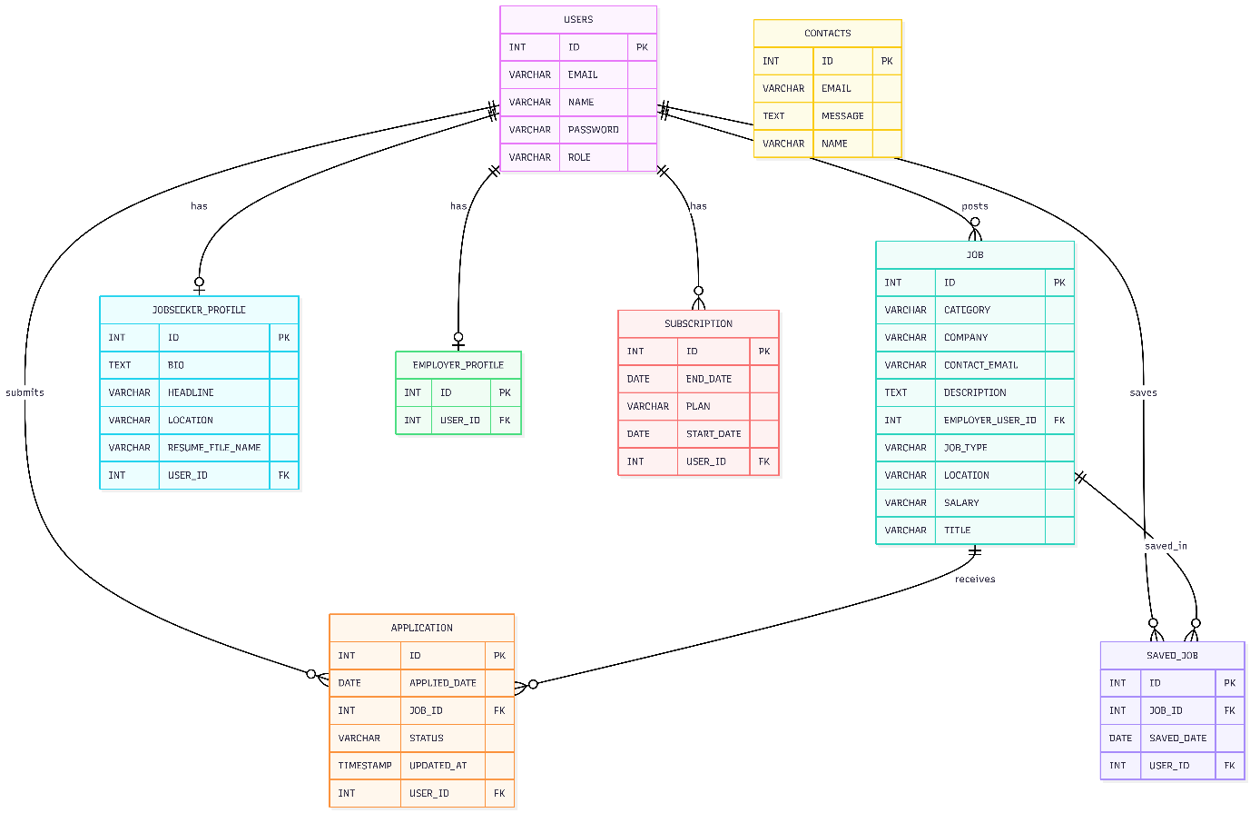
The ER Diagram shows the database structure of the Job Advertisement Portal. The USERS table acts as the central entity and connects to profile, job, application, saved job, and subscription data. This structure supports the main platform functions including job posting, job applications, profile management, saved jobs, and subscription handling

